**NLP Lab Manual**

**Practical No:01**

**A)Aim:Convert the given text to speech.**

**Code:**

# text to speech

# pip install gtts

# pip install playsound

from playsound import playsound

# import required for text to speech conversion

from gtts import gTTS

mytext = "Welcome to Natural Language programming"

language = "en"

myobj = gTTS(text=mytext, lang=language, slow=False)

myobj.save("myfile.mp3")

playsound("myfile.mp3")

**Output:**

welcomeNLP.mp3 audio file is getting created and it plays the file with playsound()

method, while running the program.

**b) Convert audio file Speech to Text.**

**Source code:**

#pip3 install SpeechRecognition pydub

import speech_recognition as sr

filename = "male.wav"

# initialize the recognizer

r = sr.Recognizer()

# open the file

with sr.AudioFile(filename) as source:

# listen for the data (load audio to memory)

  audio_data = r.record(source)

# recognize (convert from speech to text)

text = r.recognize_google(audio_data)

print(text)

Output:



**Practical No. 2:**

**a. Study of various Corpus – Brown, Inaugural, Reuters, udhr with various**

**methods like filelds, raw, words, sents, categories.**

**b. Create and use your own corpora (plaintext, categorical)**

**c. Study Conditional frequency distributions**

**d. Study of tagged corpora with methods like tagged_sents, tagged_words.**

**e. Write a program to find the most frequent noun tags.**

**f. Map Words to Properties Using Python Dictionaries**

**g. Study DefaultTagger, Regular expression tagger, UnigramTagger**

**h. Find different words from a given plain text without any space by comparing**

**this text with a given corpus of words. Also find the score of words.**

**a. Study of various Corpus – Brown, Inaugural, Reuters, udhr with various**

**methods like fields, raw, words, sents, categories,**

**source code:**

'''NLTK includes a small selection of texts from the Project brown electronic text

archive, which contains some 25,000 free electronic books, hosted at

http://www.brown.org/. We begin by getting the Python interpreter to load the NLTK

package, then ask to see nltk.corpus.brown.fileids(), the file identifiers in this corpus:'''

Code:

import nltk

from nltk.corpus import brown

nltk.download('brown')

print ('File ids of brown corpus\n',brown.fileids())

'''Let’s pick out the first of these texts — Emma by Jane Austen — and give it a short

name, emma, then find out how many words it contains:'''

ca01 = brown.words('ca01')

# display first few words

print('\nca01 has following words:\n',ca01)

# total number of words in ca01

print('\nca01 has',len(ca01),'words')

#categories or files

print ('\n\nCategories or file in brown corpus:\n')

print (brown.categories())

'''display other information about each text, by looping over all the values of fileid

corresponding to the brown file identifiers listed earlier and then computing statistics

for each text.'''

print ('\n\nStatistics for each text:\n')

print('AvgWordLen\tAvgSentenceLen\tno.ofTimesEachWordAppearsOnAvg\t\tFileName')

for fileid in brown.fileids():

num_chars = len(brown.raw(fileid))

num_words = len(brown.words(fileid))

num_sents = len(brown.sents(fileid))

num_vocab = len(set([w.lower() for w in brown.words(fileid)]))

print (int(num_chars/num_words),'\t\t\t', int(num_words/num_sents),'\t\t\t',int(num_words/num_vocab),'\t\t\t', fileid)

Output:  
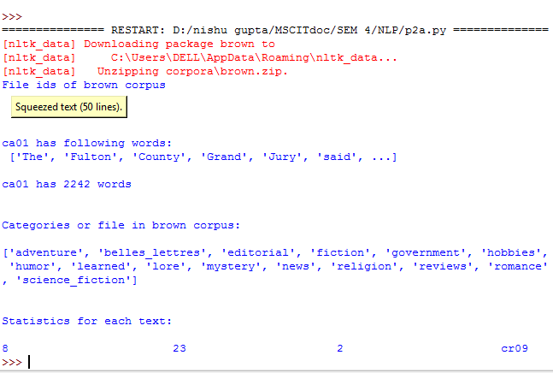

**b. Create and use your own corpora (plaintext, categorical)**

**source code:**

'''NLTK includes a small selection of texts from the Project filelist electronic text

archive, which contains some 25,000 free electronic books, hosted at

http://www.filelist.org/. We begin by getting the Python interpreter to load the NLTK

package, then ask to see nltk.corpus.filelist.fileids(), the file identifiers in this corpus:'''

Code:

import nltk

from nltk.corpus import PlaintextCorpusReader

corpus_root = 'D://nishu gupta//MSCITdoc//SEM 4//NLP//uni'

filelist = PlaintextCorpusReader(corpus_root, '.*')

print ('\n File list: \n')

print (filelist.fileids())

print (filelist.root)

'''display other information about each text, by looping over all the values of fileid

corresponding to the filelist file identifiers listed earlier and then computing statistics

for each text.'''

print ('\n\nStatistics for each text:\n')

print

('AvgWordLen\tAvgSentenceLen\tno.ofTimesEachWordAppearsOnAvg\tFileName')

for fileid in filelist.fileids():

num_chars = len(filelist.raw(fileid))

num_words = len(filelist.words(fileid))

num_sents = len(filelist.sents(fileid))

num_vocab = len(set([w.lower() for w in filelist.words(fileid)]))

print (int(num_chars/num_words),'\t\t\t', int(num_words/num_sents),'\t\t\t',int(num_words/num_vocab),'\t\t', fileid)

Output:



**c. Study Conditional frequency distributions**

**source code:**

#process a sequence of pairs

text = ['The', 'Fulton', 'County', 'Grand', 'Jury', 'said', ...]

pairs = [('news', 'The'), ('news', 'Fulton'), ('news', 'County'), ...]

import nltk

from nltk.corpus import brown

nltk.download('brown')

nltk.download('inaugural')

nltk.download('udhr')

fd = nltk.ConditionalFreqDist((genre, word)

for genre in brown.categories()

for word in brown.words(categories=genre))

genre_word = [(genre, word)

for genre in ['news', 'romance']

for word in brown.words(categories=genre)]

print(len(genre_word))

print(genre_word[:4])

print(genre_word[-4:])

cfd = nltk.ConditionalFreqDist(genre_word)

print(cfd)

print(cfd.conditions())

print(cfd['news'])

print(cfd['romance'])

print(list(cfd['romance']))

from nltk.corpus import inaugural

cfd = nltk.ConditionalFreqDist(

(target, fileid[:4])

for fileid in inaugural.fileids()

for w in inaugural.words(fileid)

for target in ['america', 'citizen']

if w.lower().startswith(target))

from nltk.corpus import udhr

languages = ['Chickasaw', 'English', 'German_Deutsch',

'Greenlandic_Inuktikut', 'Hungarian_Magyar', 'Ibibio_Efik']

cfd = nltk.ConditionalFreqDist(

(lang, len(word))

for lang in languages

for word in udhr.words(lang + '-Latin1'))

cfd.tabulate(conditions=['English', 'German_Deutsch'],

samples=range(10), cumulative=True)

**Output:**

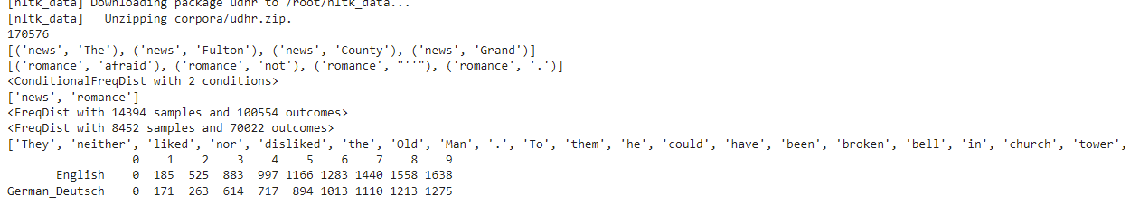

**d. Study of tagged corpora with methods like tagged_sents, tagged_words.**

**Source code**:

import nltk

from nltk import tokenize

nltk.download('punkt')

nltk.download('words')

para = "Hello! My name is Beena Kapadia. Today you'll be learning NLTK."

sents = tokenize.sent_tokenize(para)

print("\nsentence tokenization\n===================\n",sents)

# word tokenization

print("\nword tokenization\n===================\n")

for index in range(len(sents)):

 words = tokenize.word_tokenize(sents[index])

print(words)

Output:

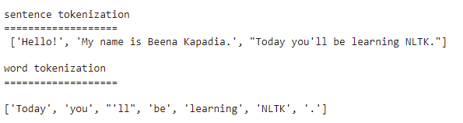

**e. Write a program to find the most frequent noun tags.**

**Code:**

import nltk

from collections import defaultdict

nltk.download('averaged_perceptron_tagger')

text = nltk.word_tokenize("Nick likes to play football. Nick does not like to play cricket.")

tagged = nltk.pos_tag(text)

print(tagged)

# checking if it is a noun or not

addNounWords = []

count=0

for words in tagged:

  val = tagged[count][1]

if(val == 'NN' or val == 'NNS' or val == 'NNPS' or val == 'NNP'):addNounWords.append(tagged[count][0])

count+=1

print (addNounWords)

temp = defaultdict(int)

# memoizing count

for sub in addNounWords:

 for wrd in sub.split():

  temp[wrd] += 1

# getting max frequency

res = max(temp, key=temp.get)

# printing result

print("Word with maximum frequency : " + str(res))

**Output:**

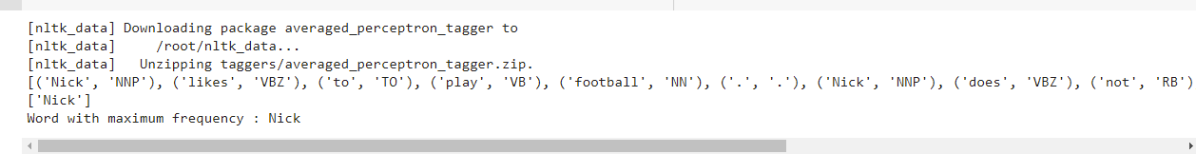

**f. Map Words to Properties Using Python Dictionaries**

**Code:**

#creating and printing a dictionay by mapping word with its properties

thisdict = {

"brand": "Ford",

"model": "Mustang",

"year": 1964

}

print(thisdict)

print(thisdict["brand"])

print(len(thisdict))

print(type(thisdict))

Output:

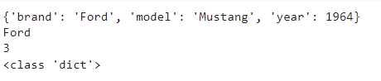

**g. Study i) DefaultTagger, ii) Regular expression tagger, iii) UnigramTagger**

**i) DefaultTagger**

**code:**

import nltk

nltk.download('treebank')

from nltk.tag import DefaultTagger

exptagger = DefaultTagger('NN')

from nltk.corpus import treebank

testsentences = treebank.tagged_sents() [1000:]

print(exptagger.evaluate (testsentences))

#Tagging a list of sentences

import nltk

from nltk.tag import DefaultTagger

exptagger = DefaultTagger('NN')

print(exptagger.tag_sents([['Hi', ','], ['How', 'are', 'you', '?']]))

Output:

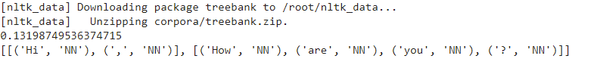

**ii) Regular expression tagger,**

**code:**

from nltk.corpus import brown

from nltk.tag import RegexpTagger

test_sent = brown.sents(categories='news')[0]

regexp_tagger = RegexpTagger(

[(r'^-?[0-9]+(.[0-9]+)?$', 'CD'), # cardinal numbers

(r'(The|the|A|a|An|an)$', 'AT'), # articles

(r'.*able$', 'JJ'), # adjectives

(r'.*ness$', 'NN'), # nouns formed from adjectives

(r'.*ly$', 'RB'), # adverbs

(r'.*s$', 'NNS'), # plural nouns

(r'.*ing$', 'VBG'), # gerunds

(r'.*ed$', 'VBD'), # past tense verbs

(r'.*', 'NN') # nouns (default)

])

print(regexp_tagger)

print(regexp_tagger.tag(test_sent))

Output:



**iii) UnigramTagger**

**code:**

# Loading Libraries

from nltk.tag import UnigramTagger

from nltk.corpus import treebank

# Training using first 10 tagged sentences of the treebank corpus as data.

# Using data

train_sents = treebank.tagged_sents()[:10]

# Initializing

tagger = UnigramTagger(train_sents)

# Lets see the first sentence

# (of the treebank corpus) as list

print(treebank.sents()[0])

print('\n',tagger.tag(treebank.sents()[0]))

#Finding the tagged results after training.

tagger.tag(treebank.sents()[0])

#Overriding the context model

tagger = UnigramTagger(model ={'Pierre': 'NN'})

print('\n',tagger.tag(treebank.sents()[0]))

Output:

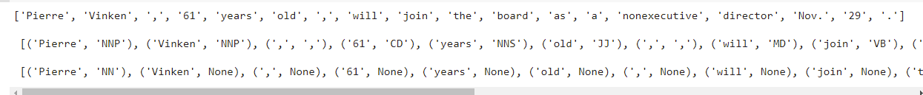

**h. Find different words from a given plain text without any space by comparing**

**this text with a given corpus of words. Also find the score of words.**

**Question:**

Initialize the hash tag test data or URL test data and convert to plain text without any

space.. Read a text file of different words and compare the plain text data with the

words exist in that text file and find out different words available in that plain text. Also

find out how many words could be found. (for example, text = "#whatismyname" or

text = www.whatismyname.com. Convert that to plain text without space as:

whatismyname and read text file as words.txt. Now compare plain text with words

given in a file and find the words form the plain text and the count of words which

could be found)

**Source code:**

from __future__ import with_statement #with statement for reading file

import re # Regular expression

words = [] # corpus file words

testword = [] # test words

ans = [] # words matches with corpus

print("MENU")

print("-----------")

print(" 1 . Hash tag segmentation ")

print(" 2 . URL segmentation ")

print("enter the input choice for performing word segmentation")

choice = int(input())

if choice == 1:

 text = "#whatismyname" # hash tag test data to segment

 print("input with HashTag",text)

 pattern=re.compile("[^\w']")

 a = pattern.sub('', text)

elif choice == 2:

 text = "www.whatismyname.com" # url test data to segment

 print("input with URL",text)

 a=re.split('\s|(?<!\d)[,.](?!\d)', text)

 splitwords = ["www","com","in"] # remove the words which is containg in the list

 a ="".join([each for each in a if each not in splitwords])

else:

 print("wrong choice...try again")

 print(a)

for each in a:

 testword.append(each) #test word

test_lenth = len(testword) # lenth of the test data

# Reading the corpus

with open('words.txt', 'r') as f:

 lines = f.readlines()

words =[(e.strip()) for e in lines]

def Seg(a,lenth):ans =[]

for k in range(0,lenth+1): # this loop checks char by char in the corpus

 if a[0:k] in words:

  print(a[0:k],"-appears in the corpus")

  ans.append(a[0:k])

  break

if ans != []:

  g = max(ans,key=len)

    return g

test_tot_itr = 0 #each iteration value

answer = [] # Store the each word contains the corpus

Score = 0 # initial value for score

N = 37 # total no of corpus

M = 0

C = 0

while test_tot_itr < test_lenth:

 ans_words = Seg(a,test_lenth)

if ans_words != 0:

 test_itr = len(ans_words)

answer.append(ans_words)

a = a[test_itr:test_lenth]

test_tot_itr += test_itr

Aft_Seg = " ".join([each for each in answer])

# print segmented words in the list

print("output")

print("---------")

print(Aft_Seg) # print After segmentation the input

# Calculating Score

C = len(answer)

score = C * N / N # Calculate the score

print("Score",score)

**Output:**

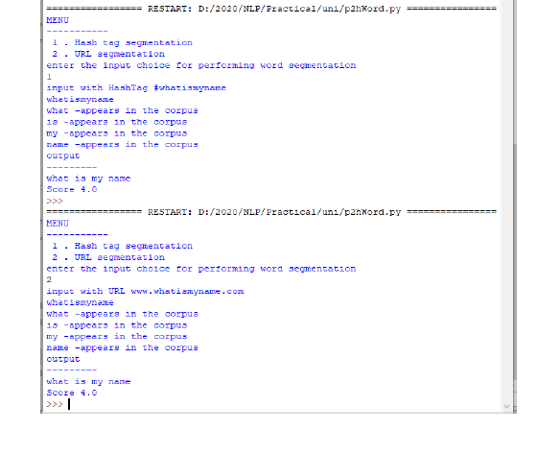

3. a. **Study of Wordnet Dictionary with methods as synsets, definitions, examples,**

**Antonyms**

**Source Code:**

'''WordNet provides synsets which is the collection of synonym words also called

“lemmas”'''

import nltk

nltk.download('wordnet')

from nltk.corpus import wordnet

print(wordnet.synsets("computer"))

# definition and example of the word ‘computer’

print(wordnet.synset("computer.n.01").definition())

#examples

print("Examples:", wordnet.synset("computer.n.01").examples())

#get Antonyms

print(wordnet.lemma('buy.v.01.buy').antonyms())

**Output:**

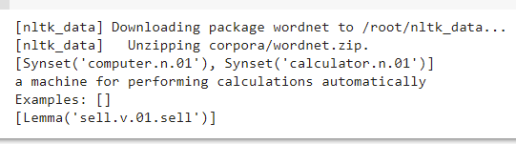

**b. Study lemmas, hyponyms, hypernyms.**

**Source code:**

import nltk

from nltk.corpus import wordnet

print(wordnet.synsets("computer"))

print(wordnet.synset("computer.n.01").lemma_names())

#all lemmas for each synset.

for e in wordnet.synsets("computer"):

  print(f'{e} --> {e.lemma_names()}')

#print all lemmas for a given synset

print(wordnet.synset('computer.n.01').lemmas())

#get the synset corresponding to lemma

print(wordnet.lemma('computer.n.01.computing_device').synset())

#Get the name of the lemma

print(wordnet.lemma('computer.n.01.computing_device').name())

#Hyponyms give abstract concepts of the word that are much more specific

#the list of hyponyms words of the computer

syn = wordnet.synset('computer.n.01')

print(syn.hyponyms)

print([lemma.name() for synset in syn.hyponyms() for lemma in synset.lemmas()])

#the semantic similarity in WordNet

vehicle = wordnet.synset('vehicle.n.01')

car = wordnet.synset('car.n.01')

print(car.lowest_common_hypernyms(vehicle))

**Output:**

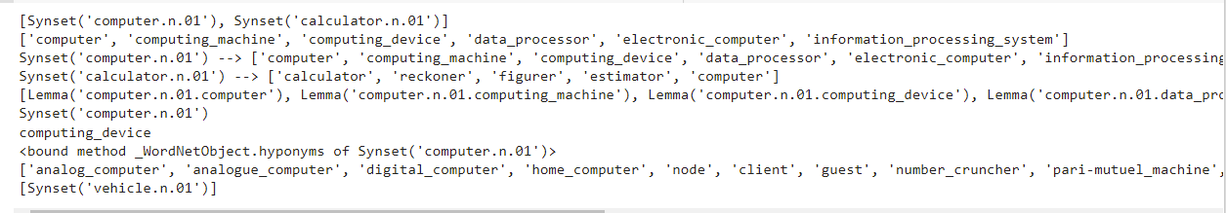

**c. Write a program using python to find synonym and antonym of word "active"**

**using Wordnet.**

**Source code:**

from nltk.corpus import wordnet

print( wordnet.synsets("active"))

print(wordnet.lemma('active.a.01.active').antonyms())

**Output:**



**d. Compare two nouns**

**source code:**

import nltk

from nltk.corpus import wordnet

syn1 = wordnet.synsets('football')

syn2 = wordnet.synsets('soccer')

# A word may have multiple synsets, so need to compare each synset of word1 with synset of word2

for s1 in syn1:

  for s2 in syn2:

    print("Path similarity of: ")

    print(s1, '(', s1.pos(), ')', '[', s1.definition(), ']')

    print(s2, '(', s2.pos(), ')', '[', s2.definition(), ']')

    print(" is", s1.path_similarity(s2))

    print()

Output:  
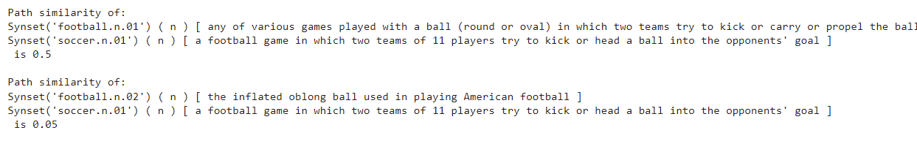

**e. Handling stopword:**

**i) Using nltk Adding or Removing Stop Words in NLTK's Default Stop Word**

**List**

**code:**

import nltk

from nltk.corpus import stopwords

nltk.download('stopwords')

from nltk.tokenize import word_tokenize

text = "Yashesh likes to play football, however he is not too fond of tennis."

text_tokens = word_tokenize(text)

tokens_without_sw = [word for word in text_tokens if not word in

stopwords.words()]

print(tokens_without_sw)

#add the word play to the NLTK stop word collection

all_stopwords = stopwords.words('english')

all_stopwords.append('play')

text_tokens = word_tokenize(text)

tokens_without_sw = [word for word in text_tokens if not word in all_stopwords]

print(tokens_without_sw)

#remove ‘not’ from stop word collection

all_stopwords.remove('not')

text_tokens = word_tokenize(text)

tokens_without_sw = [word for word in text_tokens if not word in all_stopwords]

print(tokens_without_sw)

Output:  
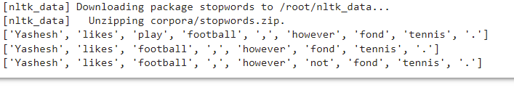

**ii) Using Gensim Adding and Removing Stop Words in Default Gensim Stop**

**Words List**

**code:**

#pip install gensim

import gensim

from gensim.parsing.preprocessing import remove_stopwords

text = "Yashesh likes to play football, however he is not too fond of tennis."

filtered_sentence = remove_stopwords(text)

print(filtered_sentence)

all_stopwords = gensim.parsing.preprocessing.STOPWORDS

print(all_stopwords)

'''The following script adds likes and play to the list of stop words in Gensim:'''

from gensim.parsing.preprocessing import STOPWORDS

all_stopwords_gensim = STOPWORDS.union(set(['likes', 'play']))

text = "Yashesh likes to play football, however he is not too fond of tennis."

text_tokens = word_tokenize(text)

tokens_without_sw = [word for word in text_tokens if not word in

all_stopwords_gensim]

print(tokens_without_sw)

'''Output:

['Yashesh', 'football', ',', 'fond', 'tennis', '.']

The following script removes the word "not" from the set of stop words in

Gensim:'''

from gensim.parsing.preprocessing import STOPWORDS

all_stopwords_gensim = STOPWORDS

sw_list = {"not"}

all_stopwords_gensim = STOPWORDS.difference(sw_list)

text = "Yashesh likes to play football, however he is not too fond of tennis."

text_tokens = word_tokenize(text)

tokens_without_sw = [word for word in text_tokens if not word in

all_stopwords_gensim]

print(tokens_without_sw)

Output:



**iii) Using Spacy Adding and Removing Stop Words in Default Spacy Stop Words**

**List**  
Code:  
#pip install spacy

#python -m spacy download en_core_web_sm

#python -m spacy download en

import spacy

import nltk

from nltk.tokenize import word_tokenize

sp = spacy.load('en_core_web_sm')

#add the word play to the NLTK stop word collection

all_stopwords = sp.Defaults.stop_words

all_stopwords.add("play")

text = "Yashesh likes to play football, however he is not too fond of tennis."

text_tokens = word_tokenize(text)

tokens_without_sw = [word for word in text_tokens if not word in all_stopwords]

print(tokens_without_sw)

#remove 'not' from stop word collection

all_stopwords.remove('not')

tokens_without_sw = [word for word in text_tokens if not word in all_stopwords]

print(tokens_without_sw)

Output:  
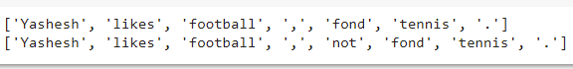

**4. Text Tokenization**

**a. Tokenization using Python’s split() function**

**code:**

text = """ This tool is an a beta stage. Alexa developers can use Get Metrics API to

seamlessly analyse metric. It also supports custom skill model, prebuilt Flash Briefing

model, and the Smart Home Skill API. You can use this tool for creation of monitors,

alarms, and dashboards that spotlight changes. The release of these three tools will

enable developers to create visual rich skills for Alexa devices with screens. Amazon

describes these tools as the collection of tech and tools for creating visually rich and

interactive voice experiences. """

data = text.split('.')

for i in data:

 print (i)

Output:

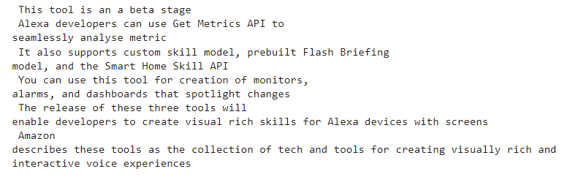

**b. Tokenization using Regular Expressions (RegEx)**

**code:**

import nltk

# import RegexpTokenizer() method from nltk

from nltk.tokenize import RegexpTokenizer

# Create a reference variable for Class RegexpTokenizer

tk = RegexpTokenizer('\s+', gaps = True)

# Create a string input

str = "I love to study Natural Language Processing in Python"

# Use tokenize method

tokens = tk.tokenize(str)

print(tokens)

Output:  


**c. Tokenization using NLTK**

**code:**

import nltk

from nltk.tokenize import word_tokenize

# Create a string input

str = "I love to study Natural Language Processing in Python"

# Use tokenize method

print(word_tokenize(str))

Output:  


**d. Tokenization using the spaCy library**

**code:**

import spacy

nlp = spacy.blank("en")

# Create a string input

str = "I love to study Natural Language Processing in Python"

# Create an instance of document;

# doc object is a container for a sequence of Token objects.

doc = nlp(str)

# Read the words; Print the words

#

words = [word.text for word in doc]

print(words)

Output:  


**e. Tokenization using Keras**

**Code:**

#pip install keras

#pip install tensorflow

import keras

from keras.preprocessing.text import text_to_word_sequence

# Create a string input

str = "I love to study Natural Language Processing in Python"

# tokenizing the text

tokens = text_to_word_sequence(str)

print(tokens)

Output:  


**f. Tokenization using Gensim**

**code:**

#pip install gensim

from gensim.utils import tokenize

# Create a string input

str = "I love to study Natural Language Processing in Python"

# tokenizing the text

list(tokenize(str))

Output:  
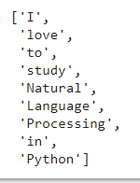

**5. Import NLP Libraries for Indian Languages and perform:**

Note: Execute this practical in https://colab.research.google.com/

**a) word tokenization in Hindi**

**Source code:**

!pip install torch==1.3.1+cpu -f https://download.pytorch.org/whl/torch_stable.html

!pip install inltk

!pip install tornado==4.5.3

from inltk.inltk import setup

setup('hi')

from inltk.inltk import tokenize

hindi_text = """प्राकृ तिक भाषा सीखना बहुि तिलचस्प है।"""

# tokenize(input text, language code)

tokenize(hindi_text, "hi")

**Output:**

['▁प्राकृ तिक', '▁भाषा', '▁सीखना', '▁बहुि', '▁तिलचस्प', '▁है', '।']

**b) Generate similar sentences from a given Hindi text input**

**Source code:**

!pip install torch==1.3.1+cpu -f https://download.pytorch.org/whl/torch_stable.html

!pip install inltk

!pip install tornado==4.5.3

from inltk.inltk import setup

setup('hi')

from inltk.inltk import get_similar_sentences

# get similar sentences to the one given in hindi

output = get_similar_sentences('मैं आज बहुि खुश हूं', 5, 'hi')

print(output)

**Output:**

['मैं आजकल बहुि खुश हूं', 'मैं आज अत्यतिक खुश हूं', 'मैं अभी बहुि खुश हूं', 'मैं वितमान बहुि

खुश हूं', 'मैं वितमान बहुि खुश हूं']

**c) Identify the Indian language of a text**

**Source code:**

!pip install torch==1.3.1+cpu -f <https://download.pytorch.org/whl/torch_stable.html>

!pip install inltk

!pip install tornado==4.5.3

from inltk.inltk import setup

setup('gu')

from inltk.inltk import identify_language

#Identify the Lnaguage of given text

identify_language('બીના કાપડિયા')

**Output:**

Gujarati

**6. Illustrate part of speech tagging.**

**a. Part of speech Tagging and chunking of user defined text.**

**b. Named Entity recognition of user defined text.**

**c. Named Entity recognition with diagram using NLTK corpus – treebank**

**POS Tagging, chunking and NER:**

**a) sentence tokenization, word tokenization, Part of speech Tagging and chunking**

**of user defined text.**

**Source code:**

import nltk

from nltk import tokenize

nltk.download('punkt')

from nltk import tag

from nltk import chunk

nltk.download('averaged_perceptron_tagger')

nltk.download('maxent_ne_chunker')

nltk.download('words')

para = "Hello! My name is Beena Kapadia. Today you'll be learning NLTK."

sents = tokenize.sent_tokenize(para)

print("\nsentence tokenization\n===================\n",sents)

# word tokenization

print("\nword tokenization\n===================\n")

for index in range(len(sents)):

  words = tokenize.word_tokenize(sents[index])

print(words)

# POS Tagging

tagged_words = []

for index in range(len(sents)):

  tagged_words.append(tag.pos_tag(words))

print("\nPOS Tagging\n===========\n",tagged_words)

# chunking

tree = []

for index in range(len(sents)):

  tree.append(chunk.ne_chunk(tagged_words[index]))

print("\nchunking\n========\n")

print(tree)

**Output:**

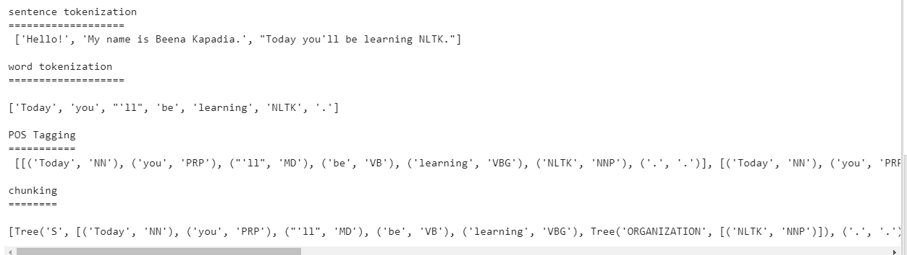

**b) Named Entity recognition using user defined text.**

**Source code:**

!pip install -U spacy

!python -m spacy download en_core_web_sm

import spacy

# Load English tokenizer, tagger, parser and NER

nlp = spacy.load("en_core_web_sm")

# Process whole documents

text = ("When Sebastian Thrun started working on self-driving cars at "

"Google in 2007, few people outside of the company took him "

"seriously. “I can tell you very senior CEOs of major American "

"car companies would shake my hand and turn away because I wasn’t "

"worth talking to,” said Thrun, in an interview with Recode earlier "

"this week.")

doc = nlp(text)

# Analyse syntax

print("Noun phrases:", [chunk.text for chunk in doc.noun_chunks])

print("Verbs:", [token.lemma_ for token in doc if token.pos_ == "VERB"])

**Output:**

Noun phrases: ['Sebastian Thrun', 'self-driving cars', 'Google', 'few people', 'the

company', 'him', 'I', 'you', 'very senior CEOs', 'major American car companies', 'my

hand', 'I', 'Thrun', 'an interview', 'Recode']

Verbs: ['start', 'work', 'drive', 'take', 'tell', 'shake', 'turn', 'be', 'talk', 'say']

**c) Named Entity recognition with diagram using NLTK corpus – treebank.**

**Source code:**

Note: It runs on Python IDLE

import nltk

nltk.download('treebank')

from nltk.corpus import treebank_chunk

treebank_chunk.tagged_sents()[0]

treebank_chunk.chunked_sents()[0]

treebank_chunk.chunked_sents()[0].draw()

Output:



**7. Finite state automata**

**a) Define grammar using nltk. Analyze a sentence using the same.**

**Code:**

import nltk

from nltk import tokenize

grammar1 = nltk.CFG.fromstring("""

S -> VP

VP -> VP NP

NP -> Det NP

Det -> 'that'

NP -> singular Noun

NP -> 'flight'

VP -> 'Book'

""")

sentence = "Book that flight"

for index in range(len(sentence)):

    all_tokens = tokenize.word_tokenize(sentence)

    print(all_tokens)

    parser = nltk.ChartParser(grammar1)

for tree in parser.parse(all_tokens):

    print(tree)

    tree.draw()

**Output:**



**b) Accept the input string with Regular expression of Finite Automaton: 101+.**

**Source code:**

def FA(s):

#if the length is less than 3 then it can't be accepted, Therefore end the process.

if len(s)<3:

return "Rejected"

#first three characters are fixed. Therefore, checking them using index

if s[0]=='1':

if s[1]=='0':

if s[2]=='1':

# After index 2 only "1" can appear. Therefore break the process if any other

character is detected

for i in range(3,len(s)):

if s[i]!='1':

return "Rejected"

return "Accepted" # if all 4 nested if true

return "Rejected" # else of 3rd if

return "Rejected" # else of 2nd if

return "Rejected" # else of 1st if

inputs=['1','10101','101','10111','01010','100','','10111101','1011111']

for i in inputs:

print(FA(i))

**Output:**

Rejected

Rejected

Accepted

Accepted

Rejected

Rejected

Rejected

Rejected

Accepted

**c) Accept the input string with Regular expression of FA: (a+b)*bba.**

**Code:**

def FA(s):

size=0

#scan complete string and make sure that it contains only 'a' & 'b'

for i in s:

if i=='a' or i=='b':

size+=1

else:

return "Rejected"

#After checking that it contains only 'a' & 'b'

#check it's length it should be 3 atleast

if size>=3:

#check the last 3 elements

if s[size-3]=='b':

if s[size-2]=='b':

if s[size-1]=='a':

return "Accepted" # if all 4 if true

return "Rejected" # else of 4th if

return "Rejected" # else of 3rd if

return "Rejected" # else of 2nd if

return "Rejected" # else of 1st if

inputs=['bba', 'ababbba', 'abba','abb', 'baba','bbb','']

for i in inputs:

print(FA(i))

**output:**

Rejected

Rejected

Accepted

Accepted

Rejected

Rejected

Rejected

Rejected

Accepted

**d) Implementation of Deductive Chart Parsing using context free grammar and a**

**given sentence.**

**Source code:**

import nltk

from nltk import tokenize

grammar1 = nltk.CFG.fromstring("""

S -> NP VP

PP -> P NP

NP -> Det N | Det N PP | 'I'

VP -> V NP | VP PP

Det -> 'a' | 'my'

N -> 'bird' | 'balcony'

V -> 'saw'

P -> 'in'

""")

sentence = "I saw a bird in my balcony"

for index in range(len(sentence)):

all_tokens = tokenize.word_tokenize(sentence)

print(all_tokens)

# all_tokens = ['I', 'saw', 'a', 'bird', 'in', 'my', 'balcony']

parser = nltk.ChartParser(grammar1)

for tree in parser.parse(all_tokens):

print(tree)

tree.draw()

Output:

 

**8. Study PorterStemmer, LancasterStemmer, RegexpStemmer, SnowballStemmer**

**Study WordNetLemmatizer**

**Code:**

# **PorterStemmer**

import nltk

from nltk.stem import PorterStemmer

word_stemmer = PorterStemmer()

print(word_stemmer.stem('writing'))

**Output:**

write

**#LancasterStemmer**

import nltk

from nltk.stem import LancasterStemmer

Lanc_stemmer = LancasterStemmer()

print(Lanc_stemmer.stem('writing'))

**Output:**

writ

**#RegexpStemmer**

import nltk

from nltk.stem import RegexpStemmer

Reg_stemmer = RegexpStemmer('ing$|s$|e$|able$', min=4)

print(Reg_stemmer.stem('writing'))

**output**

writ

**#SnowballStemmer**

import nltk

from nltk.stem import SnowballStemmer

english_stemmer = SnowballStemmer('english')

print(english_stemmer.stem ('writing'))

**output**

write

**#WordNetLemmatizer**

from nltk.stem import WordNetLemmatizer

lemmatizer = WordNetLemmatizer()

print("word :\tlemma")

print("rocks :", lemmatizer.lemmatize("rocks"))

print("corpora :", lemmatizer.lemmatize("corpora"))

# a denotes adjective in "pos"

print("better :", lemmatizer.lemmatize("better", pos ="a"))

Output:  
word : lemma

rocks : rock

corpora : corpus

better : good

**9. Implement Naive Bayes classifier**

**Code:**

#pip install pandas

#pip install sklearn

import pandas as pd

import numpy as np

sms_data = pd.read_csv("spam.csv", encoding='latin-1')

import re

import nltk

from nltk.corpus import stopwords

from nltk.stem.porter import PorterStemmer

stemming = PorterStemmer()

corpus = []

for i in range (0,len(sms_data)):

s1 = re.sub('[^a-zA-Z]',repl = ' ',string = sms_data['v2'][i])

s1.lower()

s1 = s1.split()

s1 = [stemming.stem(word) for word in s1 if word not in

set(stopwords.words('english'))]

s1 = ' '.join(s1)

corpus.append(s1)

from sklearn.feature_extraction.text import CountVectorizer

countvectorizer =CountVectorizer()

x = countvectorizer.fit_transform(corpus).toarray()

print(x)

y = sms_data['v1'].values

print(y)

from sklearn.model_selection import train_test_split

x_train,x_test,y_train,y_test = train_test_split(x,y,test_size = 0.3,

stratify=y,random_state=2)

#Multinomial Naïve Bayes.

from sklearn.naive_bayes import MultinomialNB

multinomialnb = MultinomialNB()

multinomialnb.fit(x_train,y_train)

# Predicting on test data:

y_pred = multinomialnb.predict(x_test)

print(y_pred)

#Results of our Models

from sklearn.metrics import classification_report, confusion_matrix

from sklearn.metrics import accuracy_score

print(classification_report(y_test,y_pred))

print("accuracy_score: ",accuracy_score(y_test,y_pred))

**input:**

spam.csv file from github

**Output:**



**10. a. Speech Tagging:**

**i. Speech tagging using spacy**

**code**

import spacy

sp = spacy.load('en_core_web_sm')

sen = sp(u"I like to play football. I hated it in my childhood though")

print(sen.text)

print(sen[7].pos_)

print(sen[7].tag_)

print(spacy.explain(sen[7].tag_))

for word in sen:

print(f'{word.text:{12}} {word.pos_:{10}} {word.tag_:{8}}

{spacy.explain(word.tag_)}')

sen = sp(u'Can you google it?')

word = sen[2]

print(f'{word.text:{12}} {word.pos_:{10}} {word.tag_:{8}}

{spacy.explain(word.tag_)}')

sen = sp(u'Can you search it on google?')

word = sen[5]

print(f'{word.text:{12}} {word.pos_:{10}} {word.tag_:{8}}

{spacy.explain(word.tag_)}')

#Finding the Number of POS Tags

sen = sp(u"I like to play football. I hated it in my childhood though")

num_pos = sen.count_by(spacy.attrs.POS)

num_pos

for k,v in sorted(num_pos.items()):

print(f'{k}. {sen.vocab[k].text:{8}}: {v}')

#Visualizing Parts of Speech Tags

from spacy import displacy

sen = sp(u"I like to play football. I hated it in my childhood though")

displacy.serve(sen, style='dep', options={'distance': 120})